Issue 26
March 2022

In this Issue
Covid-19 update
Discovery College
Can you identify this?
Helix Arts
Death Cafes
Patient Forum Working Groups
Living Well North Tyneside
Healthwatch
SEND-Special Educational Needs and Disability
North Tyneside Carers Centre
Screening Programmes
NHCFT
Did you know?
Message from the Chair

Patient Forum Newsletter
Welcome to the latest Patient Forum Newsletter. We have many items of news and updates which we hope will be useful to you.

Coronavirus (COVID-19)
For NHS information please click here
For Government guidelines please click here
For local information please click here

North Tynesides Young Person’s Discovery College
VODA is delighted to announce the launch of the North Tyneside Young Person’s Discovery College in partnership with Barnardo’s The Base and funded by the North Tyneside CCG. Built on the Recovery College model, The Discovery College aims to support young people (16-25), to better manage their own mental health and wellbeing.
The Discovery College will offer young people, workshops, courses and activities that are co-designed and co-produced by young people. Access to the college will be free to all 16 to 25-year-olds living across North Tyneside, by an easy self-referral process. Read more.
Please share this information with young people who you feel would be interested in getting involved. Contact jessica.shaw@voda.org.uk for more information.

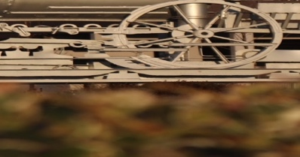
Can you identify this?
A North Tyneside local landmark, can you spot what it is and identify where it is?
Answer on the last page.

Helix Arts
Helix Arts is an arts charity that has collaborated and connected with local people, partners and artists for almost 40 years, helping improve their health, their prospects, their communities, and their environments. Why not take a look at our website at some of the ways you can get involved.

Heritage Action Zone
Do you want to learn how to run your own creative project and turn your ideas into reality?
Make It Happen and get involved to gain new skills and to co-design your own art event showcasing your unique ideas and explore the heritage and future of Howard Street in North
Shields.

If you are a young person, a community member or a local
artist, contact Elizabeth at elizabeth.kane@helixarts.com to start your creative journey.

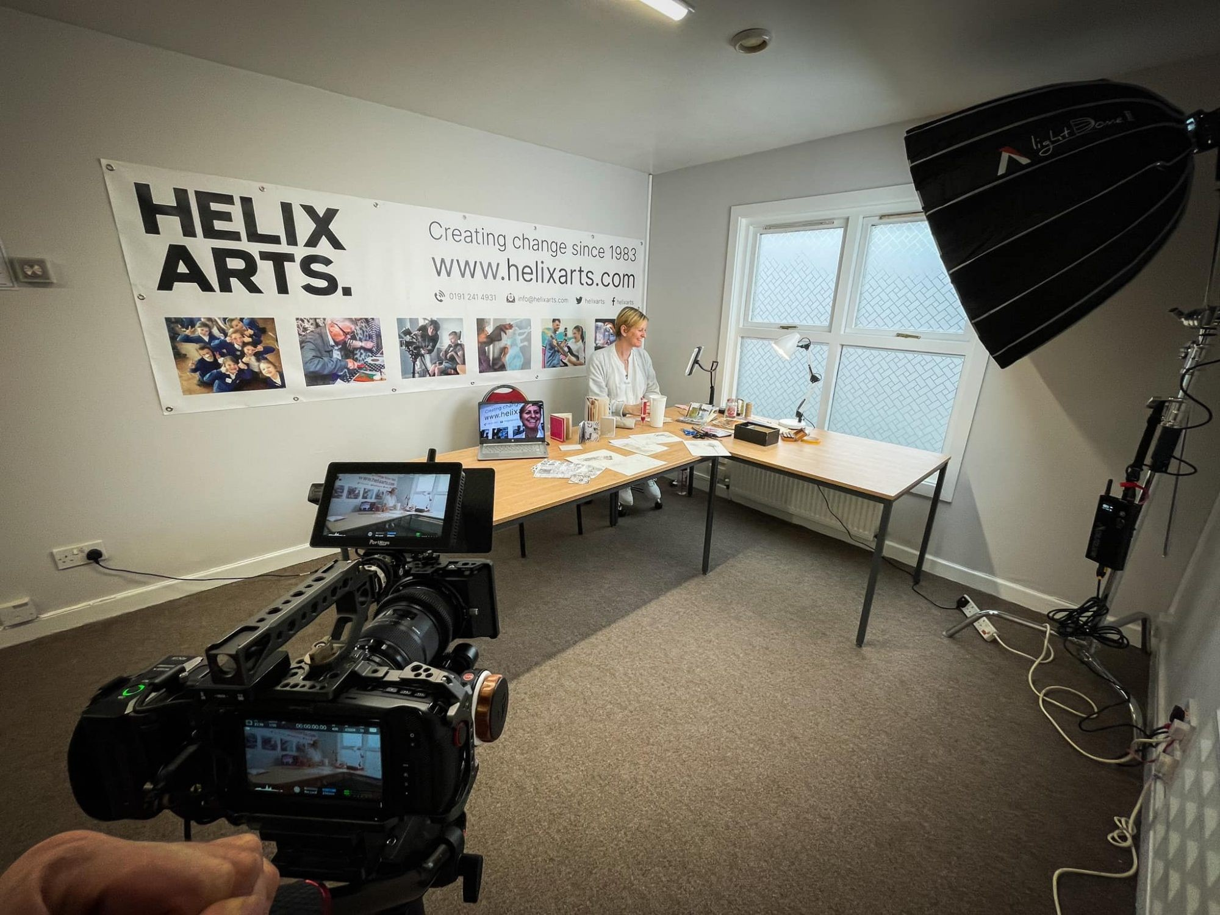
Are you an individual who has caring responsibilities?
HeArt of Care is a global project with the aim of uniting carers and encourages them to share their experiences as carers through a creative medium.
Three initial masterclasses have been created which we encourage carers to take part in. This includes a calming micro-teach of creative journaling with artist Jessica Kinnersley.
Want to try one of the masterclasses yourself? Head to https://www.helixarts.com/work/heart-of-care/ to take a look.

HeArt of Care forms part of our social prescribing programme, Better Connect.
If arts and culture was on prescription, what would that look like? Share your ideas with us by giving us a call on 0191 241 4931 or drop us your ideas in our website ‘tell us more form’.

Become a Trustee
Are you an enthusiastic individual that wants to make an impact and has a desire to influence new development? We are seeking new Trustee’s to join our board. Want to apply or find our more?
Head to our website www.helixarts.com and ‘Get Involved’ Now!
Death Cafes
Not morbid or a funeral plan sales pitch just an opportunity to talk about the one thing we all have in common.

The Community Development team at the Linskill Centre hosted their own death Café and this was led by the Macmillan Support Services Coodinator. Attendees enjoyed the café and felt as well as increasing their skills and knowledge it had a positive effect on their mood. Additional feedback included;

- A perfect chance to discuss a topic the we generally don't speak about.
- Open conversations in comfortable surroundings. The meeting was introduced and supported in an excellent manner
- The sort of questions in the Grave talk pack were very useful
- A chance to open up about a difficult subject

When asked how they would you describe the session to a friend, they said;
- A guided discussion on attitudes toward death and grief
- A great opportunity to have a frank, open and sometime funny conversation, to normalise death and to consider how to open up to those important to you.
- Chance for someone who is unwilling to consider issues of mortality to be gently introduced to subject
- An enjoyable chat responding to some interesting questions

To arrange your own Death Café please contact;
Angela Belshaw by telephone 0191 2934376 or email angela.belshaw@nhct.nhs.uk

Patient Forum Working Groups
These examples show the wide range of areas members are involved with and more information can be found by folling this link
https://www.northtynesideccg.nhs.uk/get-involved/patient-forum

Members are preparing for the annual Development Session in June to look at their many achievements. There are six Working Groups and each has a specific work plan with direct involvement in future planning and highlights of achievements will feature in the June issue.

The six working groups are: Communications, End of Life, Future Care, Innovations, Mental Health and Engagement.
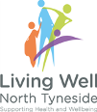
Living Well North Tyneside
The latest issue of the Living Well North Tyneside magazine can be found here. The magazine complements the website which was launched last year during the summer and includes a directory of health, wellbeing and social care services.
Visit the website at www.livingwellnorthtyneside.co.uk

Healthwatch North Tyneside
What matters to you?
Healthwatch North Tyneside want to hear about your health and care experiences in their annual survey. This is the chance for you to say thank you to the services you've used and have your say about what you think could be improved.
Healthwatch share your feedback with service providers and commissioners; and identify ways they can improve their services to make health and care better for everyone.
Share your views for a chance of winning a £50 Love to Shop voucher. https://healthwatchnorthtyneside.co.uk/haveyoursay/annual-survey-2021/
For a paper copy telephone 0191 263 5321 or email info@hwnt.co.uk

SEND
Special Educational Needs and Disability
The Local Offer provides information for children, young people (from birth to 25 years) and families. Information, services and support available in North Tyneside is available via this link.
https://my.northtyneside.gov.uk/category/1243/local-offer-special-educational-needs-and-disabilities-send

North Tyneside Carers Centre

If someone depends on you, you can depend on us.
As a Carer you may provide unpaid practical and emotional support to a family member, friend, partner or neighbour who could not manage without you due to an illness, disability, substance misuse or mental health.
North Tyneside Carers’ Centre are an independent charity and the only generic carer support service in North Tyneside supporting both Young and Adult Carers.

Do you know how to look after yourself?
Along with the support from the Recovery College we are running a group of Self-Care sessions to provide Adult carers with the skills to enable them to:
- Understand what self-care is and what it is not.
- Be in a position to decide what self-care is appropriate for you.
- Have the skills to incorporate some self-care it into your daily / weekly routines.
- Be inspired to explore and incorporate more self- care routines into your life.

“Acknowledge, accept and honour that you deserve your own compassion and love”
Carer Surgeries
Our Carer Community Link Workers, Andrea, Jacqui and Sue are running Adult Carer Surgeries in GP practices across North Tyneside. We would like to give you the opportunity to book an appointment with us, to meet in the surgery to discuss your carer role. We will provide information, advice and a kind, non-judgemental listening ear. Hopefully you will leave with a more positive plan on balancing your carer role with your own needs.

Carer Surgeries are currently being held in:
Wellspring Surgery, Killingworth 2:30–5:30pm on the 2nd Thursday of every month.

Village Green Surgery, Wallsend 10am – 12pm on the last Friday of each month.

Both surgeries are by appointment only. Further sessions are to be arranged in North Shields in the near future.

For further information on this article please contact Andrea, Jacqui or Sue our Carer Community Link Workers, Tel 0191 6432298

Screening programmes
Breast screening saves around 1,300 lives every year in the UK.

If you are aged between 50 and 70 years old and registered with a North Tyneside GP, you will receive an invitation in the post when it is your turn to be invited.
Breast cancer is the most common cancer in the UK. The NHS breast screening programme aims to detect breast cancer at a very early stage before there are any symptoms and when treatment is most effective.

If you are concerned about changes with your breasts, do not wait for your screening appointment and seek advice from your GP straight away. For information on approximately when invitations will be sent out for your GP practice, scan the QR code. To make or change an appointment please ring 0191 2820202.

Bowel Cancer Awareness Month
Bowel cancer is the 4th most common cancer in the UK.
Most people with symptoms such as bleeding, changes in bowel habit, unexplained weight loss, extreme unexplained tiredness or pain/ a lump in their tummy don’t have bowel cancer. Other health problems can cause similar symptoms. But if you have one or more of the above, or if things just don’t feel right, go to see your GP. Learn how to reduce your risk on the NHS and Bowel Cancer Awareness websites.

The NHS bowel cancer screening checks if you could have bowel cancer. It's available to everyone aged 60 to 74, and 56 year olds. It is a simple test that checks for any blood in the poo is done at home. It can detect very early signs of cancer when treatment is most effective.

Your GP will automatically send you a testing kit to be done at home every 2 years. Or you can call 0800 707 60 60 to get a test kit sent to you.

Extended Access Cervical Screening Clinics
Cervical screening is available for everyone with a cervix between 25 and 64. Cervical screening is a quick test to check if there have been any changes in your cervical cells.
There are appointments available across the borough 7 days a week, with clinics running until 8pm. The appointments are provided by local experienced doctors and nurses who work in North Tyneside GP practices and have full access to your medical records.

Appointments can be booked by contacting your own GP practice or when your practice is closed, via the TyneHealth Extended Access Appointment number 0191 486 2195.

The NHS screening programmes are essential for reducing the number of people finding cancer at a late stage when treatment is less effective. Make sure you get booked in for any screening you’re eligible for. Screening saves lives.

Become the heartbeat of your local NHS
Northumbria Healthcare NHS Foundation Trust
If you’re passionate about the NHS, then joining Northumbria Healthcare as a member will give you the opportunity to share your thoughts and ideas about the way the trust deliver care to over half a million people across Northumberland and North Tyneside. Northumbria Healthcare are a very forward thinking organisation, twice rated outstanding by the CQC and at the forefront of pioneering changes in the NHS, so it’s a great time to join us.

Membership is open to anybody aged 12 and over and you can be involved as much or as little as you like. As a member you will be informed about trust work, vote for and be able to stand as a governor as well as benefit from NHS discounts in shops and online at www.healthservicediscounts.com .

It is free to become a member and you can opt out at any time. If you would like to join you can sign up online at https://www.northumbria.nhs.uk/get-involved/join-our-our-foundation-trust/become-a-member/ or scan the QR code.

Did you know…

Between December 2020 to February 2022 VODAs volunteer programme supported a number of important tasks;
256 volunteers stepped up to provide vital support to the clinical staff, in roles ranging from escorting vulnerable people through the vaccine process, greeting and directing people to cleaning down furniture and surfaces.
374 separate clinics including The Langdale Centre, Wallsend – The Oxford Centre, North West and The Parks covering the North Shields and Whitley Bay areas, with the Parks clinic moving to the Royal Quays in September 2021. In addition, VODA supported a further three pharmacy led clinics from June 2021 to September 2021 located at The Memorial Hall, Wallsend, White Swan Centre and Marden Residents Association.
70,000 vaccines delivered
2,618 hours worked by volunteers, sometimes each clinic required 24 volunteers split over 3 shifts.

Eleanor Hayward Chair of the Patient Forum
Thank you to all of the members for their continued enthusiasm at the Forum and Working Groups. This quarterly newsletter aims to share current health information and some of the excellent services provided in North Tyneside. If you would like to suggest articles of interest please get in touch.

Location - Stephenson's Rocket, Killingworth roundabout.
The Rocket was designed by Robert Stephenson in 1829. Heralded as the most advanced locomotive of its day and became the template for most steam engines for the following 150 years.

This newsletter is produced quarterly by members of the CCG Patient Forum Communications Working Group

If you like the sound of the Patient Forum and would be interested in being part of it please contact; Michele Spencer michele@chcfnorthtyneside.org.uk for more information

